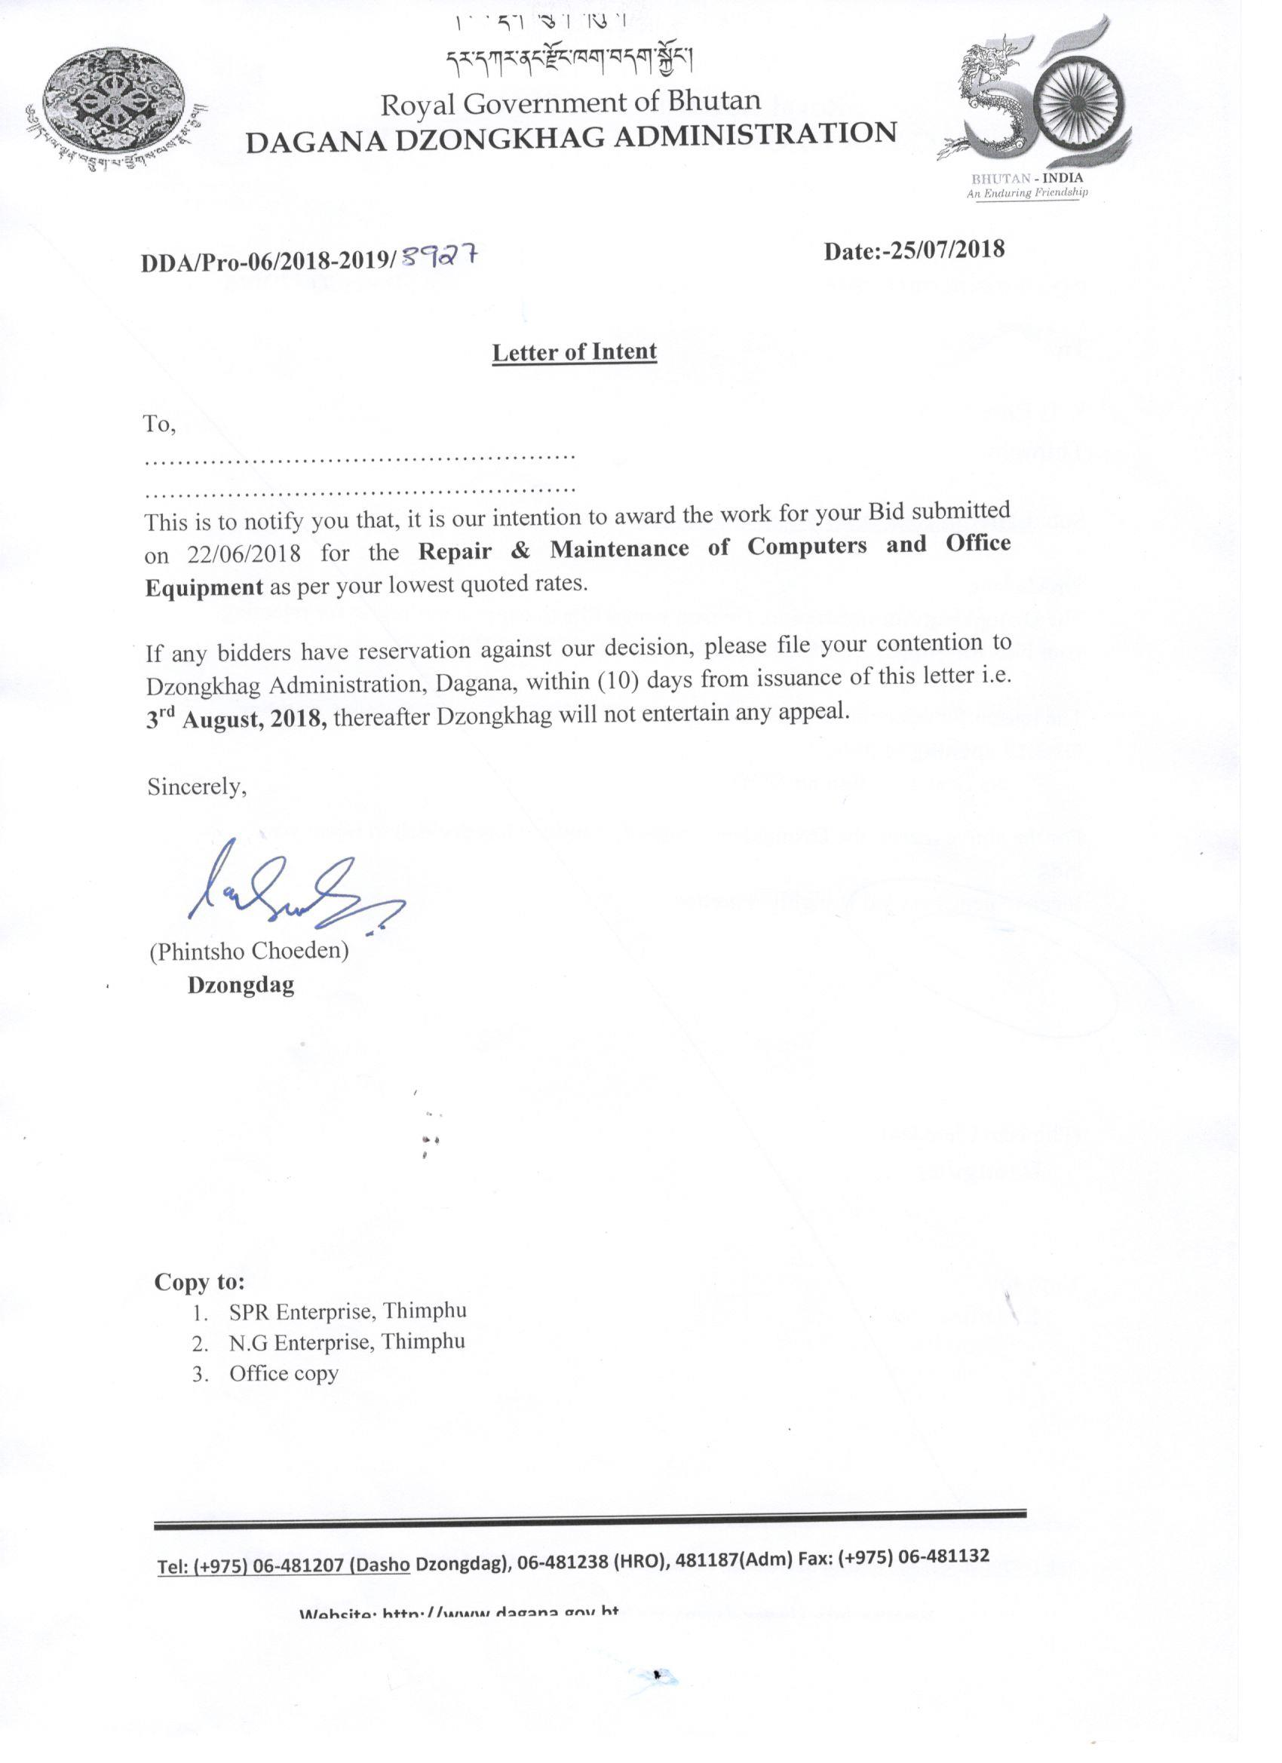
Repair and Maintenance of Computers and Office Equipment for 2018-2019
Sl. No. | Particulars | Unit | SPR Enterprise Rate | N.G Enterprise Rate
1 | Mother board | Each | 18,445 | 2500
2 | Laptop Battery | Each | 6445 | 4600
3 | Laptop keyboard | Each | 4445 | 2100
4 | Desktop keyboard | Each | 3645 | 680
5 | Laptop bag | Each | 3800 | 6000
6 | Genuine window 8 operation & installation (MS office & Quick heal antivirus) | Set | 5400 | 12000
7 | RAM 4 GB | Each | 5400 | 3800
8 | RAM 8 GB | Each | 6945 | 5300
9 | Laptop Screen | Each | 6300 | 6900
10 | Laptop Fan | Each | 2845 | 3800
11 | Network Adopter | Each | 9800 | 2500
12 | Servicing charge for laptop & computer | Each | 4600 | 800
13 | Servicing charge for laptop & computer | Each | 4600 | 800
14 | Drum unit photocopy machine | Each | 12445 | 6400
15 | printer fan | Each | 4000 | 2500
16 | hard disk 500GB | Each | 5200 | 3900
17 | Display board | Each | 7200 | 6400
18 | Touch pad | Each | 4600 | 5100
19 | USB port hub | Each | 4000 | 3800
20 | USB mouse | Each | 2600 | 410
21 | Speaker internal | Each | 4100 | 4100
22 | Blade and roller photocopy machine | Each | 12400 | 2500
23 | Roller assembly | Each | 10400 | 3100
24 | Developer/pick up roller | Each | 9800 | 4300
25 | Projector repair/service charge | Each | 4600 | 1500
 | Total items |  | 6 items | 19 items
 | Total |  | 164,015 | 95,790

